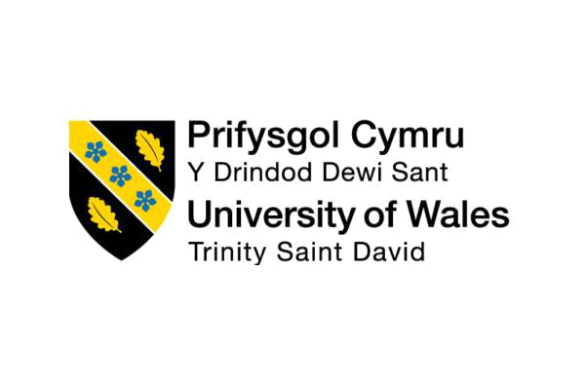

Vision for the Future: Theoretical Perspective on

Management

1

Executive Summary

There are several types of traditional organisational structures and theories such as Mintzberg organisational structure, mechanistic and organic organisational structure, functional departmentalisation, Geographical departmentalisation, customers’ departmentalisation, multidivisional structure, multinational structure, matrix organisations etc. These types of organisational structure have been popular to several areas. Due to the inventions of technology and other modern needs, these kinds of structures are not creating appeal as much as previous. Thus, there is the need to comply with the emerging trends of technology and other devices.

There are several management theories applied by the organisations working both in local and international market areas. Management theories are understood and applied by the managers in order to increase the productivity and performance by the organisations.

From the analysis of UK retail industry especially in case of the structure followed by them, it has been observed that a mix type of structure is followed where most of the firms are following the hierarchical structure and others are following flat or decentralised in most of the cases. Technology has a greater impact on the current structure followed by the firms where a typical change in the structure is recommended for the firms.

In this era especially in the contexts of e commerce and web 2.0 technologies, hierarchical structure has a little value as it hinders the growth for the firms and limit the learning opportunities for the employees at several key areas. Flat organisations are suggested to the next decades and firms who are responsive to the changes will become successful in the contexts of next eras. Decentralised management system allows to quick decision making with the help of technologies and skills by them.

2
Table of Contents

Executive Summary 2

1.0: Introduction: 4

2.0: Literature review: 5

3.0: Traditional structures of organisations: 6

4.0: Several traditional management theories: 23

5.0: Technological advances and the traditional organisational structure: 25

6.0: Organisational structure at the UK retail industry and impact of technology on the

industry 25

7.0: Conclusion: 29

8.0: References: 31

3
Example 2:
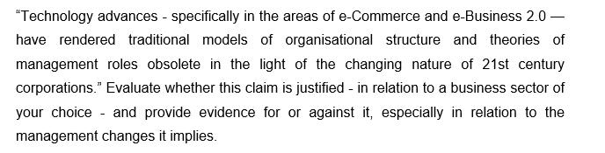

1.0: Introduction:

Today there are several innovations and technological advances in the areas of businesses and other daily lives. Due to the innovation of technology and its devices, the way business functions are executed has changed a lot. Compared to the previous centuries, functions by the business enterprises have become automated and it has increased the efficiency of services. Both the organisations and customers are benefitted a lot through the use of technology. Ecommerce and e-business 2.0 have changed the styles of operational contexts in almost all the functional areas. The aim of this assignment is to analyse how these technological advances have rendered traditional models of organisational structures and theories obsolete in the context of 21st century organisations. Not necessarily, the traditional models of organisational structures and theories have become obsolete rather there are lots of amendments in those theories to be applicable in the context of modern organisational contexts.

The retail industry of UK is one of the prominent industries where technology has impacted a lot to the smoother operations. Several organisations are rendering various automated services to the target consumers. The specific objective of this report is to analyse how technology has been being used in this: industry to flourish the services.

4
2.0: Literature review:

Drucker (2013) argued that E-commerce and e-business are two main components of the modern transaction and operation system. E-commerce which is also known as electronic commerce and internet commerce refers to the process where the physical products are sold online and the trade is facilitated through the use of several electronic devices. Once goods are sold manually where both the consumers and retailers got physical interaction. But nowadays there is no requirement to have physical substance from both the parties to have the transactions being executed (Arvinen-Muondoand Perkins, 2013).

E-business on the other hand refers to the whole process of continuing of an online business. Thus, it can be argued that e-commerce is a subset of e-business (Arvinen-Muondo and Perkins, 2013).

According to Chen (2018), there are four types of e business such as B2B which is Business to Business indicating the selling of goods between businesses to business. Selling of raw materials to Tesco, the retail giant in UK constitutes B2B types of transaction. The second type is B2C which is business to consumers indicating the selling of goods and services to the consumers. The selling of goods and services to the consumers of Tesco is an example of B2C. C2C is another type of e-business where consumers sell goods and services to the business organisations. C2B is consumers to businesses in where several consumers sell goods and services to the business organisations using the online and other supportive flat forms (Drucker, 2013).

There are several types of traditional organisational structures and theories such as Mintzberg organisational structure, mechanistic and organic organisational structure, functional departmentalisation, Geographical departmentalisation, customers’ departmentalisation, multidivisional structure, multinational structure, matrix organisations etc (Farmer et.al 2013). These types of organisational structure have been popular to several areas. Due to the inventions of technology and other modern needs, these kinds of structures are not creating appeal as much as previous. Thus, there is the need to comply with the emerging trends of technology and other devices.

5

According to Taylor (2015) advancement of technology especially in the areas of e commerce and web 2.0 has rendered businesses to change the current structure they are following. On the other hand, organisations need to comply with the changing trends of technology to utilise the structure fully. Flat or decentralised organisational structure has a greater appeal in the present days and has a greater impact on the all the sectors especially in the retail industry where IT and IT enabled services have a greater impact.

3.0: Traditional structures of organisations:

Gilmoreand Williams (2017) argued that traditional organisational structures have the stems back in two centuries. Several scholars of management and other scientific areas developed several organisational structures those are used in several organisational contexts. Whenever these models were introduced by the scholars of several areas according to the needs of trends, technology was not so advanced as today. Thus, there is the need to incorporate the use of technology to make this model workable. However, among several structures, Mintzberg model is popular which is based on five core areas as follows

Mintzberg's Org. Structure and Configurat

Operating core: This segment is assigned to the productions of necessary goods and services to the target consumers (Anthony et.al 2017).

Strategic apex: This is the top-level management of any organisation.

Middle line: This segment is composed of the managers who are situated in the middle of operating core and strategic apex (Carpenter and Sanders2014).

Techno structure: This department is liable to the designing and processing of outputs to the target market so that the objectives by the firms are met successfully.

Support staffs: There are various staffs outside the organisations that provide supports except for the production of goods and services.

6
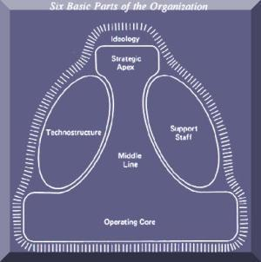

Figure: Mintzberg Organisational structure

Source: Farmer et.al (2013)

According to Mintzberg there are five types of organisational structures as follows

Blend of strategy, environmental forces and the organizational structure define the types and nature of organisations.

Entrepreneurial

According to Arvinen-Muondo and Perkins (2013), exactly in this type of organisation, there is low focus on the structure by the organisations where entrepreneurial minds and leaders get the top-notch priority. This type of structure is normally found in case of newly established firms. There is the evidence of low tasks discipline, in efficiency and

7

controlling the management systems are the main drawbacks of this kind of organisational structure.

Machine bureaucratic organisation:

In this type of structure, a large hierarchy of management is found. Most of the cases for government and other big firms, this management style is followed. The two main strengths of this type of management style is consistency and longevity (Carpenter and Sanders 2014). There is low scope to express opinion by the others and there is low scope of innovation in the service areas.

Professional

This kind of structure has a greater similarity with bureaucratic organisational system. The main point of difference here is the knowledge base by the employees and expertise in the given fields. Professionals typically have strong command over the jobs they are doing (Carpenter and Sanders 2014). Because there are too many professionals in the organisations, the decision-making process is de centralized in the contexts of given areas. Schools, colleges, universities and several other law firms follow this kind of structure.

Organisations are benefited through the strong decision-making power by the superiors where the junior level employees are required to follow a rigid organisational structure.

The divisional or diversified organisational structure:

According to Drucker (2013), there are so many firms following a diversified product portfolio in the operations where several product departments are managed from a single authority. There are several MNCs and other geographically diversified organisations follow this kind of organisational structure.

There are several product line managers who are in full control with the management activities and take the accountability of the actions by them. The centralized

8

management always focus on the big pictures and make long term plans for the operations in the other areas.

Among several weaknesses, one is duplication of the resources. Moreover, there is the propensity to have conflicts among the managers regarding the allocation of resources from the headquarters. This kind of organisational structure is effective when the organisations are large in nature and have the continuity in the development of products and services in several areas (Carpenter and Sanders 2014). Moreover, effective centralised decision making is done through the proper management functions.

The innovative organisations(Adhocracy)

Not necessarily, a same organisational structure is applicable to all kinds of organisations. The models so far have been discussed are applicable for the firms engaged in the management of traditional activities. In several cases, there is the requirement for continuous innovation where previously discussed models are not so effective rather innovation leads the path to become successful (Drucker andMaciariello, 2017)l.

Filmmaking, pharmaceuticals and several other industries always look for individuals and processes which are enough dynamic to cope up with the changing trends. In this form of organisational structure, decentralized decision-making process is applicable and power of authority is delegated to several parties whatever needed (Drucker, 2013).

Experts move from projects to projects as they become completed. This kind of organisational structure is flexible enough to the employees and they can freely cope with the changing trends of innovation in several areas (Taylor, 2015).

Despite several advantages, there are several drawbacks of the system such as the delegation of authority, conflicts of interests, and experts’ availability for all the time being etc.

So far by the discussion, several organisational structures are revealed. With the emergence of technology and other web-based tools and Medias, the nature of the

structure by the organisations are changing (Drucker and Maciariello, 2017). For example, there is the emergence of virtual organisations where downsizing is a common issue. There is no more presence of traditional organisational structures rather a flat structure is followed. Intense innovation in this era has led to the obsolete of several models of traditional organisational management and activities.

Mechanistic and organic structure

Arvinen-Muondo and Perkins (2013) argued that Mechanistic and organic structures are two popular ways for managing the structures by the organisations. In case of mechanistic structure, employees are required to follow a routine work which may be rigorous in nature and they all will be held as responsible for the works done. This kind of structure is not so far effective in this technology led areas. There is the resistance to change in this type of structure. On the other hand, organic structure is responsive to changes and employees feel flexibility in working in this kind of structure (Drucker and Maciariello, 2017).

There are several characteristics of both mechanistic and organic types of structures. Firstly, characteristics of mechanistic organisations are as follows

There is low level of authority decentralisation

- Higher specialisation is focused

- Higher formalisation of each activity

- There is the emergence of rapid departmentalisation

- Decisions are made in the centralised ways there the span of control is limited only to the top-level authority.

- There is the strong chain of command followed among the structure.

Secondly, organic structure follows several characteristic as follows

- Teams are made within the experts from several functional areas

- There is the wider span of control compared to the low span

- Decisions are made in the decentralised ways

10
- Lower chain of command\

- Higher level of flexibility while working among several groups and geographical areas
- Information is being transmitted in free flow of manner

From the comparison of these two types of organisations, it has been revealed that the later one is more adaptive to the emerging trends of technologies and change responsive environment. Employees seek to learn on a continuous manner and through a process where higher freedom of activities is existed. Thus, the organic structure is useful to the functions conducted by the present types of needs and demands in the markets.

Organisational culture:

Drucker (2013) argued that culture is made up of shared values, beliefs, the ways decisions are made etc. Culture plays a crucial role to the successes in several key areas. The culture by the organisations is largely dependent on the structures of different types followed by the organisations. The culture developed through mechanistic structure is totally different from that of organic structure.

Being too much cautious, obeying a strong layer of management, being obedient to the decisions and authorities by one is typically stressed in the form of mechanistic organisational structure (Farmer et.al 2013). On the other hand, being creative and responsive to changes, flexibilities in the decision-making process, being a risk taker, handing of the risks is always promoted in case of the organic structure.

Functional departmentalisation:

In this kind of organisational structures, jobs are allocated to different functions such as finance, accounts, marketing, management etc. there is the divisional head in each area and others are working under the head of the functional areas. The heads of several departments are under the control of Chief Executive Officer in this kind of structure

11

(Arvinen-Muondo and Perkins 2013). There are several advantages and disadvantages for following this kind of organisational structure as follows

Advantages:

- Improved decision making in the functional areas as there is the emergence of common skills by several people in the same functional areas
- Greater coordination of the works by the functional teams and members

- There is the presence of in-depth specialisation

Dis advantages:

- Most of the cases it has been found that juniors are overwhelmed with the seniors
- There is the lack of communication among several functional divisions

- Functional areas are busy with the goals by the head of the department where the common big goals by the firms are not considered seriously

There are several characteristics of functional departmentalisation as follows

Specialisation by functions: In this type of structure, employees are typically found to work under a single function where there is less scope of innovation and work force flexibility. Emphasize is given only to one specific functional area (Chen, 2018).

Emphasis on sub goals: It is important to give proper importance on the prime goals by the organisations whereas in this case, the goals of departments are given the priority. The link between the goals of functional areas and goals in general to the organisation if is misread, the aims and objectives by the firms are hampered seriously (Drucker, 2013).

Tall structure: There is the existence of a complex organisational system in this case. The higher layers between the low- and top-level management hinders the growth by the organisations (Arvinen-Muondo and Perkins 2013).

12

Pyramid growth of organisations: The growth of organisation is dependent on the proper decision-making power by the higher-level authority. Each department is headed by a functional head and others follow the instructions led by the respective head of functional areas (Drucker and Maciariello, 2017).

Limited span of management: In most of the cases, it has been found that, a single department is busy with the tasks embedded on it only where there is the lack of linkage among the other functional areas which is also important to the growth of organisations (Chen 2018). It is important to know on the dependency and collaboration by several functional areas to reach a holistic objective by the firms.

Advantage of functional departmentalisation:

In case of the organisations following functional departmentalisation there is the positioning of all the experts in several functional areas such as accounting, finance and other common areas and jobs are done in more arranged ways (Armstrong and Armstrong 2014). There is the better coordination of the activities and acts are rooted to achieve functional advantages. Centralisation of activities is focused here. There are several advantages for operating under the functional departmentalisation as follows

- Firstly, there is the logical reflection of functions and activities where power and prestige of the departments is core to perform
- Occupational specialisations’ principles are followed strictly

- There are the arrangements for proper training and supervision to the subordinates from the top level authority so that functions can be done in the most accurate and coherent manner

- So that works is done within the prescribed time limit strong command for activities and tight of control are prevailed at the organisation

- There is the scope that departments are furnished with skilled employees at that special fields such as personnel from finance under the finance department and such at the other departments
- There is the ease of co-ordination among the functional areas

13

Disadvantages of functional departmentalisation:

Such as the benefits, there are several disadvantages of operating under the functional departmentalisation as follows

- Firstly, the operation and the decision-making process through the bureaucratic system which time consuming and costly in nature

- In most of the cases it has been found that focus is strongly made on the achievements of functional objectives rather on the corporate goals which is a major drawback of operating under the system

- It has become tough to monitor accountability and performance by the employees

- Overspecialisation is focused and the key personnel are underestimated in various times thus leading to dissatisfaction among the employees

- In achieving the goals of organisations there is the requirement to have a cross functional activities which is lack under the management thus in most of the cases organisational achievements are not fulfilled

- The top-level authority is held as responsible for earning and meeting the profit target where there is the low or fewer involvement by the juniors and others who to become the next leaders at the organisational contexts

- Under the management system there is tardiness to adopt changes as when required. Because in most of the cases aged personnel belong at the top of the authority and they are unlikely to adopt changes in several areas despite the importance of that (Armstrong and Armstrong 2014). Modern environment always prefers to adopt changes as it is the demand of the current trends.

- In most of the cases employees are promoted to next level based on years of experience rather the performance by them each point of time which is a major obstacle for general managers for growth and sustain at the organisations

Both advantages and disadvantages happen under the functional departmentalisation. Several manufacturing and government organisations follow the management where this approach is no more used in case of technology-based firms and in the firms

14

growing rapidly in several areas of operations (King and Lawley 2013). This management is more suitable where there is one or very few products and services to be developed and in small organisations.

Geographical departmentalisation:

Armstrong and Armstrong (2014) argued that when the functions of organisations are grouped to several geographical areas then it is called geographical departmentalisation. Functions are accomplished in several territories where each territory is maintained separately other than the centralised management system. There is less co-ordination of activities from head office to geographical areas.
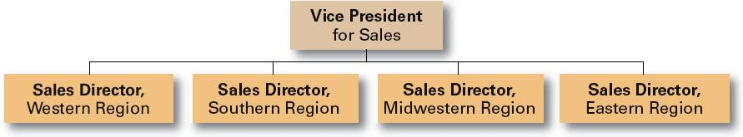

Figure: Geographical departmentalisation

Source: King and Lawley (2013)

Advantages of geographical departmentalisation:

According to Chen (2018), departmentalisation by geographical areas firstly is used to lower the costs of operation and to capitalise several opportunities as they arise in several geographical areas. Several advantages of geographical departmentalisation as follows

- Responsibilities to local level employees can be placed well and there is the strong division of labour in several geographical areas

- There is the better co-ordination of activities in several geographical areas and opportunity to grip the economics of activity at several geographical areas
- It is possible to have the one to one communication in several territorial areas

15

- There are the possibilities to have enough growth and facilities for the general level managers and they get appraised as when required

Disadvantages of geographical departmentalisation

There are several disadvantages of geographical departmentalisation as follows

- There are the provisions to have more persons normally and all to have the abilities like the general managers so that the territories can achieve the target

- It is very tough in most of the cases to co-ordinate the activities between the central offices and territories

- Sometimes it is important to have the personal from the local areas and purchase department to be furnished from the local people

- Not always the top-level management can exercise the level of control as there is the distinct of activities between the operational areas thus proper excellences may not be achieved always

- It may happen that isolation exists among the several territories and with the core offices

Product departmentalisation:

Product departmentalisation is based on the premise that all the activities are aimed to develop and offer a specified product under the one manager (King and Lawley 2013). Grouping of activities aims to furnish excellences in the specific products or services.
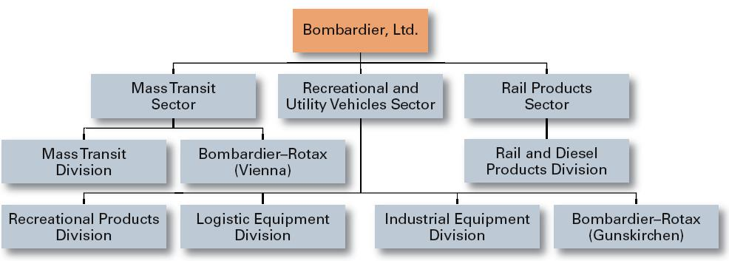

Figure: Product departmentalisation

Source: Chen (2018)

Advantages of product departmentalisation:

There are several advantages of product departmentalisation as follows

- Firstly, principles of specialisation of the products and services are followed strictly which ensures the quality goods and services in the market areas

- Because there is the focus of activities on only one product or services the full utilisation of human and non-human resources can be happened in most of the cases

- Because the products are the main of operation, the large manufacturing firms can be benefitted well through the operation system. There shall be various products and allocation of employees at several product areas

- There is the ease of controlling each department as they will be evaluated through the specific products and services, they develop in the market areas

- Enough time can be consumed by the top-level managers for planning and designing of activities as each department will be held as responsible for the actions to that department only

- Flexibility is ensured under the management system. Moreover, new products or services can be developed easily under the management system

- Through operation at this system, managers and other related employees get skilled in the specific product areas and there is the greater scope of learning and development by those

Disadvantages of product departmentalisation:

Such as advantages exist, there are several disadvantages of product departmentalisation as follows

- Chances are high that conflict of interests happen among the several product departments

17

- If there are the lower demands for the products or services in specific field, resources are utilised at lower level in that product department

- It is difficult for the top-level management to observe the activities by several product departments at a time and several lacking in the co-ordination of activities among the several product departments

- May be the overall goals by the organisation are not focused by the product managers as they are busy only with the products and services, they plan to execute in the market areas

Customer departmentalisation:

King and Lawley (2013) argued that Customer departmentalisation is based on the principle that grouping of activities shall be made according to the several types of customers organisations like to serve. If the customers are at several territories then grouping of activities shall be done in those territorial areas.
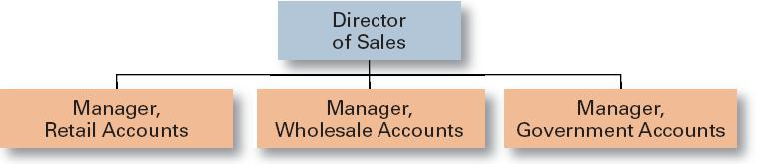

Figure: Customer departmentalisation

Source: King and Lawley (2013)

Advantages of customer departmentalisation:

There are several advantages of customer departmentalisation as follows

- Firstly, it is possible by the firms to meet the special and specific needs and demands by the customers
- Higher possibility to earn the satisfaction of the customers

18

- If the customers can be served well there shall the possibility of maintaining long lasting relationships with those customers

- Focus on customer centric approach will be made which will enhance the performance by the firms

Disadvantages of customer departmentalisation

There are several disadvantages of customer departmentalisation as follows

- There is the higher possibility that duplication of services in several areas will be made
- Higher scope being lazy by the personnel under the management system

- As there is the higher emphasize on customer satisfaction related programs less emphasize will be made in other areas where there is significant investment by the organisations

Multidivisional structure:

In a multidivisional organisational structure, it has been observed that a parent company owns several divisions where the divisions are given a significant level of autonomy in order to run the business (Farmer et.al 2013).

Advantages of multidivisional structure:

- Typically, workers get a significant control over the activities they do that makes the flexibility being ensured at the organisational level.

- Secondly, there is the requirement to accomplish ongoing changes and through a common notice to all this has been arranged successfully

- Because more concentration is given on the performance of the divisions, divisions become effective to the overall success by the firms

Disadvantages of multidivisional structure:

- It is costly compared to the other forms of structure and become less viable for the businesses small in nature

19

- Secondly, there is less communication among the departments thus making the communication process less effective

Matrix structure:

(Farmer et.al 2013) argued that in a matrix structure, reporting system is grid such that both to functional managers and reporting managers. Matrix structure allows for specialisation and in-depth knowledge by the workers which is the major advantage for operating under the system. Several disadvantages of matrix structure include the level of complexity under the system which increases higher manager to worker ratio. Moreover, it is hard to take the decisions when one side of managers are unwilling to take the decisions.

Multinational structure:

In case of multinational organisation, several offices are factories are set by such corporation at least in one country other than the parent location from where the global management is controlled.
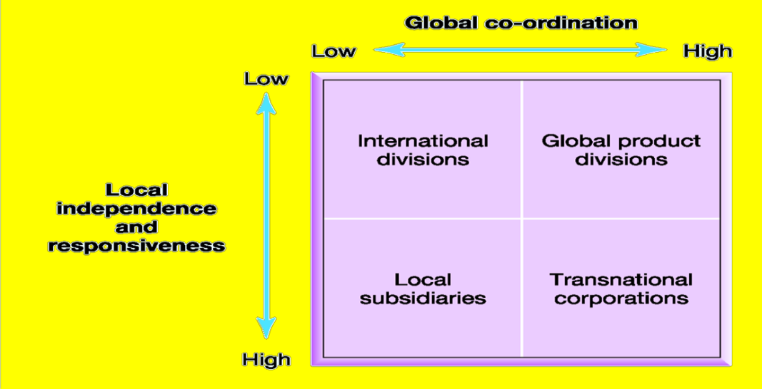

Figure: Multinational structure

Source: Chen (2018)

20

There are four basic choices when firms wish to operate in the international premises such as
- International strategy

- Transnational strategy

- Global strategy and

- Multi domestic strategy

These are described shortly

International strategy: Works better where there is low skill by the locals. Strong marketing operation and centralised management are important.

Multi domestic strategy: In order to satisfy the local needs by the consumers, there is the immense customisation of the products and offerings by the international players.

Global strategy: It is focused on standardisation and low costs structure. However, if the responsiveness by the locals is low then the strategy is not much effective.

Transnational strategy: Transnational strategy differs from the global strategy is the sense that it puts importance on the personalized marketing and selling approaches in order to sell and attract target market.

While firms operate in the international market there is the continuous pressure to cut costs so that more market share can be gripped. On the other hand, responsiveness is important to have success in the given areas. These both criteria make the firms learning organisation while operating in the international market areas.

Project based structure:

According to (Saloner et.al (2018), in a typical project-based structure, firms are created form the personnel from several departments with project specific skills for a certain time period. For a specific time period, projects remain valid and get dissolved as soon as projects end.

Comparison of organisational structures:

21

Though there are several organisational structures, not necessarily all the structures are useful for a typical organisation rather based on the operation and nature of works the suitability of the
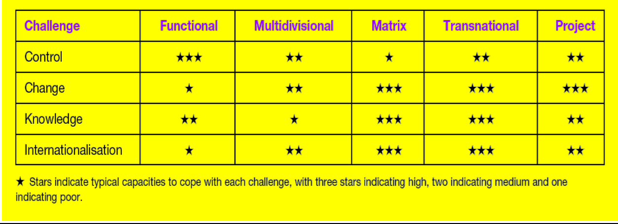

Figure: Comparison of organisational structure

Source: Saloner et.al (2018)

From the perspectives of the organisations that wish to operate in the global market place translation structure of the organisation is best for them. Because under this form of structure, several key dimensions to become successful can be achieved easily and the dimensions are knowledge gathering, proper internationalisation, control of activities and success in the international market areas (Saloner et.al 2018). On the other hand, in case of the organisations which just exist to execute specific projects both nationally and internationally there is the higher suitability of project based organisational structure. Not always these two types of organisational structure work better rather in some areas where functional structure of the organisation works better. As an example, the government organisations can be explained where divisions or functional team are accomplished and these are ready to serve the needs of the organisations.

22
4.0: Several traditional management theories:

There are several management theories applied by the organisations working both in local and international market areas. Management theories are understood and applied by the managers in order to increase the productivity and performance by the organisations. Several management theories are described here

Scientific management theory:

Frederic Taylor first introduced the scientific concept to increase the performance by the employees at the workforce. According to Taylor, rather being forced, making the works easier so that all can understand and accomplish are the prime factors to become successful at the organisational contexts.

According to Taylor money is the main motivator for the employees to keep themselves satisfied and he introduced “fair day’s wages for a fair day’s work” concept which got much popularity and started to become working within very short period of time.

Systems management theory:

Systems management is based on the alternative ways to do planning and arrangement of activities. According to the theory, like human body is composed of several parts and all the parts need to work smoothly for the proper functioning of the body, an organisation is composed of several parts such as synergy, interdependence, and interrelations between various subsystems and these all work need to work smoothly in order to proper success of the organisations. Managers are required to understand several functional units as well as all the other employees at the organisational contexts. It is important to have a better co-ordination among the employees and functional units to make a better organisation.

Contingency management theory:

Contingency management theory is believed to be one of the most effective management theory to be applied for the success of the organisations (Arvinen-Muondoand Perkins 2013). According to this management theory, there is no one best

management theory applicable in all the organisations rather several factors impact exactly which management theory will be applicable for specific type of organisation. And the factors are size of the organisation, technology and the styles of leadership being followed at the organisational contexts. Leaders might be quick to take the appropriate decisions. Moreover, LPC which is Least Preferred Co-worker is used to assess how the managers are at the given workforce.

Theory X and Theory Y:

According to theory X, employees shall dislike the workforce they belong to and they are less passionate to the work (Hersey et.al 2017). They normally dislike to work within the given workforce. Workers seem to work less in the absence of incentives. There is no scope of building collaborative and trust-based relationships among the managers and other sub ordinates.

On the other hand, according to theory Y, employees like to work better without any coercion from the top-level authority and they feel comfort while working at the workforce (King and Lawley 2013). They have a positive outlook regarding the organisation and there is the possibility for the creation of managers-workers relationship. The rate of success is normally better as employees do better at their own efforts being used.

Bureaucratic management approach:

Saloner et.al (2018) argued that in case of this management approach, there is higher layers of management starting from top to down and to approve a decision or key activity, there is the requirement for passing all layers of management which is very time consuming and costly in nature. As the time passes this management approach has a less tendency to be used in the organisational contexts.

24

5.0: Technological advances and the traditional organisational structure:

According to Arvinen-Muondoand Perkins (2013), structure is designed in such a way that the resources by the organisations are best utilized under several systems and ways. On the other hand, with the advances of technologies and application of those in the given work areas, there has been dramatic accomplishments by the organisations. Technologies change the viewpoints and the ways works are to be completed. There is a greater importance of technology on the structures by the organisations (King and Lawley 2013). For example, it can be said that when there is the greater availability of computerized operations, groups can accomplish their tasks virtually. It is not necessary that all the members of the group to be present visibly in order to accomplish a task. Not necessarily all the people to be in a single room or place to execute a meeting or to deliver an important piece of information. Due to the impact of technology positions can be either created or lost. Once there was the requirement for several file clerks to accomplish the activities which is less common in the context of modern organisations (Sinha, 2013). Files are not transferred electronically and there are the fewer requirements for clerks to bear files. Thus, the layers of management have been shirking compared to the traditional layers of management. It is important that all the persons working in the modern organisations are technically advanced. Because the technology changes of ways the works need to be completed, there is the ongoing pressure to change the structure by the organisations to be fit in the modern workforce.

6.0: Organisational structure at the UK retail industry and impact of technology on the industry

From the analysis of the UK retail sector and organisations in this respective sector, it has been observed that several organisations follow several types of organisational structure and there is a huge impact of technology on the structures designed by those. Companies in this sector are becoming successful due to the following of technology supportive structure (King and Lawley 2013).

25

Firstly, the case of Tesco comes into focus which a multinational leading grocery store having headquartered at England. The organisational structure shows that it follows hierarchical structure. So as to smoother functioning of activities several layers of management are assigned to specific departmental tasks (Easterby-Smith et.al 2013). The board of directors remain top of authority and has assigned the top-level executives to be responsible for most of the activities. However, in case of the stores there are the evidences of lacking of coordination among the managers’ activities due to the four layers of management. Flow of smoother transmission of information is hampered and finally the quality of servicing has been deteriorating a lot. The innovation of technological advances and proper functioning of those seem less need of such several layers of management to conduct the operations (Sinha, 2013). The technological advances require less layers of management in order to conduct the operational activities smoothly. Thus it can be argued that advancement of technology impacts largely on the structure currently followed by the organisation. Moreover, technology argues fewer employees to have completed the tasks smoothly at several key areas. In case of bureaucratic structure followed by Tesco, there is the requirement of more employees than the case of technology based less layer structure. Ultimately cost structure is impacted by the technology positively which urges for low cost operation. In near future, Tesco has already planned to change the current level of layers and would adopt the new technology. It will both impact services positively and reduce the costs of operation through cutting the numbers of employees.
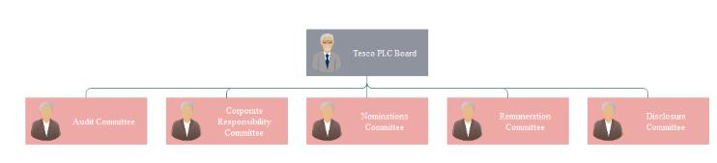

Figure: Organisational structure of Tesco

Source: Arvinen-Muondoand Perkins (2013)

26

According to Easterby-Smith et.al (2013), from the organisational structure followed by Sainsbury’s it has also shown that the organisation follows the hierarchical structure where several levels of management are held to perform the key functions of the organisation. Each level of controlled by the level next to that from the top of the organisational chart. Formula one racing car technology has been installed to smoother functioning of activities such as saving energy, time, costs and making the shoppers chill while operations are continued. The impact of technology on the structure is such that it puts pressure to accelerate the functions to the customers (King and Lawley 2013). There is the requirement of skilled employees so as to continue the operations smoothly at the organisation. In near future the organisation has planned to reduce the layers of management and taking innovative strategies in the structural designs at the organisational level.

From the analysis of organisational structure at Aldi it has been learnt that the organisation follows decentralised management system. The current structure followed by the organisation allows several regional levels of managers to take time effective strategies to meet the needs of the customers at different times. Aldi has been experiencing both advantages and disadvantages for operating under the current structure followed at several regional and city areas. For the operations in several other geographical areas such as at US and other the organisation follows a different strategy where the functions and key activities are headed by the chief executive officer at those areas. Aldi has already well known regarding the impact of technology and has installed activities especially in the areas of structural designs such as reducing the layers of management in the operational context (Hersey et.al 2017). It has benefitted both to earn operational excellences as well as reducing the burden of over employees at the organisational levels. At a flat organisational structure like followed by Aldi, accurate decisions can be easily taken as the employees engaged at different ground level activities are given the authority to take the decisions. In most the cases, it has happened that bureaucratic organisational structure requires more time to execute any decision in the key functional and cross functional areas whereas technology-based structures allow less time to execute the decisions as involvement of fewer layers of

27

management (Saloner et.al 2018). The speed of accurate services increases the performance of the organisations.

Asda another leading supermarket in the UK follows the hierarchical organisational structure. The management is convinced that experienced and senior level managers can take accurate decisions and mangers are held as responsible for the motivation and learning of the other levels of employees at the organisation. Technology has impacted a lot on the current level of organisational structure (Sinha, 2013). Technology argues less employees being employed can earn superior operational excellences if they are properly trained and take the time to time actions important for the organisation. In the supermarket areas, almost all the activities are controlled through the efficient technology-based services where more layers of management do not create any extra value to both decision-making areas and to earn operational excellences. In case of higher layers of management at the organisational structure, communication is affected negatively and in most of the times important decisions are taken at later end which hampers growth and potentiality to sustain in these competitive market areas.

Primark which is one of the top listed retail shops in the UK has been following most probably the tallest layers of management to function the activities it has at several areas. The impact of such lengthy structure is that it hinders proper communication on the key activities as to take a decision in any of the areas of the areas, several layers of management need to have approval on that. Thus, key decisions are hampered due to the current structure of the organisation. Already the organisation has planned to replenish the current organisational structure as the organisation needs to sustain in the long run through smoother operations.

Mark and Spencer which is another big player in the retail industry of UK have been following a flat organisational structure. There are both advantages and disadvantages for operating under the structure system. Information is flown timely to the required levels of mangers quickly as there are fewer layers of management in the structure. The current structure is supportive to technology-based operations. In typical technology

28

supportive functions, everything is controlled and monitored through the use of online and other IT enabled services.

From the analysis of UK retail industry especially in case of the structure followed by them, it has been observed that a mix type of structure is followed where most of the firms are following the hierarchical structure and others are following flat or decentralised in most of the cases. Technology has a greater impact on the current structure followed by the firms where a typical change in the structure is recommended for the firms (Easterby-Smith et.al 2013). It is easily predicted that in the near future technology will lead the business where retail sector is one of the key sectors to capitalise the advantage of technology. In this era especially in the contexts of e commerce and web 2.0 technologies, hierarchical structure has a little value as it hinders the growth for the firms and limit the learning opportunities for the employees at several key areas. Flat organisations are suggested to the next decades and firms who are responsive to the changes will become successful in the contexts of next eras. Decentralised management system allows to quick decision making with the help of technologies and skills by them (Hersey et.al 2017). Both learning opportunities and earning potentiality shall be boosted through the use of flat organisations in the next areas where decentralised management structure shall be focused.

7.0: Conclusion:

With the advancement of time and technologies, the environment for operations in several areas is changing rapidly. The contexts of old and new eras are totally different. There are so many traditional organisational structures and designs which though have a lot of appeal in several organisational may not be as effective as supposed to due to the technological advances. Several industries require several types of organisational structure. Technology argues for a flatter organisational structure where decentralised management system enhances the efficiency of the employees through continuous

29

learning and development. In today’s world, it is possible to operate smoothly with fewer skilled employees and application of technology enabled services.

30

8.0: References:

Anthony, R.N., Govindarajan, V. and Dearden, J., 2017. Management control systems (Vol. 9). Boston, MA: Irwin McGraw-Hill.

Armstrong, M. and Armstrong, M. (2014). Armstrong's handbook of strategic human resource management. London: Kogan Page.

Arvinen-Muondo, R. and Perkins, S. (2013). Organizational behaviour. London: Kogan Page.

Bondarouk T, Ruël H and Looise J, Electronic HRM In Theory And Practice (Emerald 2015)

Bhaskar, A.U. & Mishra, B., 2017. Exploring relationship between learning organizations dimensions and organizational performance. International Journal of Emerging Markets, 12(3), pp.593–609.

Candyindustry.com (2017).Technology[online] Available at:

https://www.candyindustry.com/topics/2667-technology [Accessed 11 Oct. 2017].

Carpenter, M. and Sanders, G. (2014). Strategic Management. Harlow: Pearson Education Limited.

Chanda A and Shen J, HRM Strategic Integration And Organizational Performance (Response Books 2018)

Chen, C. (2018). Strategic human resource practices and innovation performance: the mediating role of knowledge management capacity. Strategic Direction, 25(6).

Drucker, P. and Maciariello, J. (2017).Management. London: Collins.

Drucker, P., 2013. Management. Routledge.

31
Easterby-Smith, M., Thorpe, R. and Jackson, P.R., 2013. Management research. Sage.

Editorial Board. (2014). Human Resource Management Review, 24(3), p.IFC.

Farmer, M., Yellowley, W. and Smith, P. (2013).Organizational Behaviour. London:

Taylor & Francis Ltd.

Gilmore, S. and Williams, S. (2017). Human resource management. Oxford: Oxford University Press.

Hayter, C. (2017). Overview of the UK population - Office for National Statistics. [online]

Ons.gov.uk. Available at: https://www.ons.gov.uk/peoplepopulationandcommunity/populationandmigration/populat ionestimates/articles/overviewoftheukpopulation/mar2017 [Accessed 14 Oct. 2017].

Hersey, P., Blanchard, K.H. and Johnson, D.E., 2017. Management of organizational behavior (Vol. 9). Upper Saddle River, NJ: Prentice hall.

Ibisworld.co.uk. (2017).Chocolate& Confectionery Production in the UK Market Research | IBISWorld. [online] Available at: https://www.ibisworld.co.uk/industry-trends/market-research-reports/manufacturing/manufacture-of-food-products/chocolate-confectionery-production.html [Accessed 12 Oct. 2017].

Jeffs, C. (2015). Strategic management. Los Angeles: SAGE.

King, D. and Lawley, S. (2013). Organisational behaviour. Oxford: Oxford University Press.

Palmer, G. (2017). UK firms 'failing to prepare' for regulation changes after Brexit.

[online] The Telegraph. Available at: http://www.telegraph.co.uk/business/2017/06/29/uk-firms-failing-prepare-regulation-changes-brexit/ [Accessed 14 Oct. 2017].

Saloner, G., Shepard, A. and Podolny, J. (2018).Strategic management. New York, N.Y.: Wiley.

32

SHRM 2012-2013 Health Care Benchmarking (Society for Human Resource Management 2012)

SHRM 2015-2016 Human Capital Benchmarking

Sinha, J. (2013). Culture and organisational behaviour. New Delhi: SAGE.

Statista. (2017). UK: number of social network users 2015-2022 | Forecast. [online] Available at: https://www.statista.com/statistics/553530/predicted-number-of-social-network-users-in-the-united-kingdom-uk/ [Accessed 11 Oct. 2017].

Taylor, F.W., 2015. Scientific management.Routledge.

Tsui A and Lai K, Professional Practices Of Human Resource Management In Hong Kong(Hong Kong University Press 2013)

33

